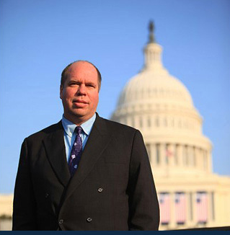

Name: Bernt Rainer Wahl
Occupation: Scientist/ Entrepreneur/ Professor
Age: 53

My education and qualifications are:

I am seeking the 15th California District State Assembly Office to serve our East Bay community and state. For over 20 years I have lived here drawn to the area’s unique character, charm and diverse population. A citizenry comprised of merchants, laborers, activists, naturalists, service workers, builders, designers, engineers, students, academics, and other concerned citizens.

The East Bay should be a place of opportunity for economic as well as social development. Strategically located, our goal should be to increase opportunity for the people who live here whether it is through enhanced employment opportunities, superior education, or just a better quality of life. As your state assembly representative, I will make economic opportunity a top priority as well as education, government transparency, the environment, and analytic decision-making.

I have the experience to get the job done. I started businesses, helped grow firms, served as a State Department Fulbright Fellow, taught 2,000 university students, and advised cities. I have worked on economic development issues ranging from local growth (Berkeley Start-up Cluster) to the United Nations (Eco-Tourism). My passion is to enable citizens. Many people I have worked with started successful enterprises. Please support me to build a better future for California by sending me to represent you in in the State Assembly.

Education:
Mathematics and Physics BA/BS UC Santa Cruz
Business Administration MBA UC Davis
Multimedia MA CSU East Bay
Information Sciences MIMS UC Berkeley
Real Estate AA Peralta Colleges
Data Science PhD (Candidate ABD) UC Santa Cruz

